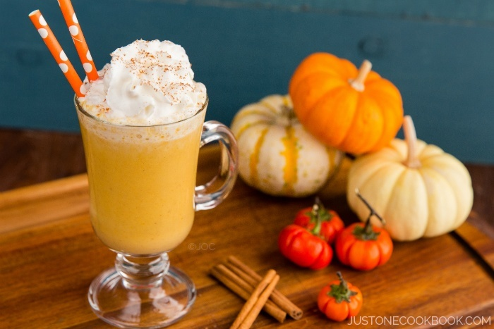

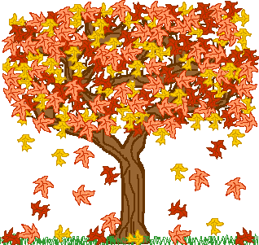



**Seasonal Menu**

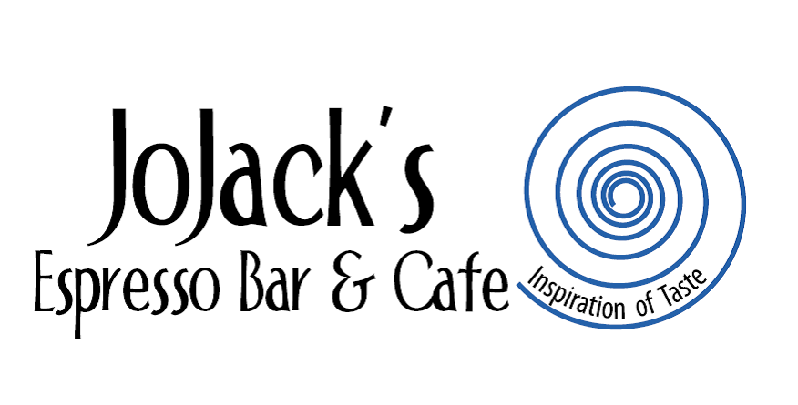

**Seasonal Breakfast Selections**

**Pumpkin Praline Pancakes**

Fluffy Pumpkin-Pecan Pancakes drizzled with our rich Caramel Praline Sauce and your choice of 2 eggs, bacon strips, pork sausage or chicken sausage. $11

**Healthy Harvest Breakfast Bowl**

House Roasted Butternut Squash, Sautéed Spinach, Caramelized Onions, Fresh Baby Spinach and our Italian Sausage all served over our Stone ground grits and topped with parmesan Cheese and an Over-Easy Egg. $10

**Autumn Omelette**

This 3 egg omelette is stuffed with Feta cheese, Sautéed Onions, Baby Spinach, Roasted Red Peppers and Roasted Butternut Squash. Served with your choice of Toast, Pan Fried Potatoes, Stone- ground Grits or our Famous Potato cakes. $10

**Seasonal Lunch Selections**

**Hand Carved Turkey Hoagie**

Hand carved Turkey breast topped with Sharp Cheddar Cheese & Our Apple Cranberry Chutney, sitting on a bed of sautéed Spinach and stuffed into a Soft warm Demi Roll with our Lemon Rosemary Mayonnaise. Served with Chips and a Pickle $11

**Pumpkin Brie Panini**

We have made a Pumpkin Brie and spread it on a Ciabatta Bread and added some fresh Baby Spinach, crispy Bacon, and our Apple & Cranberry Chutney. This Sweet & Savoury Sandwich will definitely get you in the Autum Spirit. Served with chips & a pickle $10

**Fall Festival Salad**

A bed of mixed greens topped with grilled Chicken and Honey Rosemary Quinoa, Sautéed with seasoned Pecans and Roasted Butternut Squash with fresh Blackberries, Feta Cheese and our house made Blackberry Vinaigrette dressing. $12

**Butternut Squash & Basil Shrimp Pasta Bowl**

Tender Penne Pasta tossed with Baby Spinach, Roasted Butternut Squash, Marinated Basil Shrimp and Roasted Red Peppers, all in a light White Wine Sauce and topped with freshly grated Parmesan Cheese. Served with a French Baguette $13

**Seasonal Drink Selections**

Cranberry Apple Italian Soda

Pumpkin Frappe  
Apple Pie Latte ( Served Hot or Iced)

Pumpkin Latte ( Served Hot or Iced)