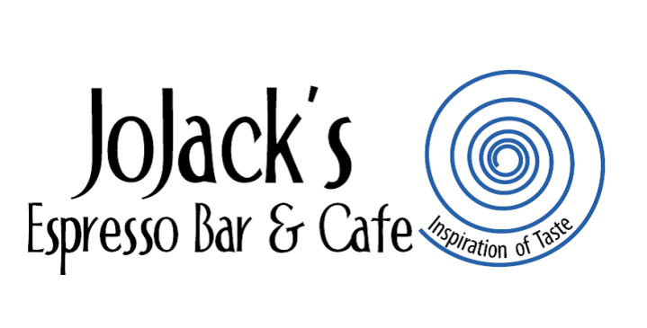

**C:\Program Files (x86)\Microsoft Office\MEDIA\CAGCAT10\j0298897.wmf**

**OCTOBER SOUP SCHEDULE**

[](http://www.google.com/url?sa=i&rct=j&q=&esrc=s&source=images&cd=&cad=rja&uact=8&docid=FiW0vqv3tlG-PM&tbnid=RFS1OWn1aN_xRM:&ved=0CAcQjRw&url=http://www.clker.com/clipart-bowl-of-soup-3.html&ei=EsUuVLTCBoL7iwKBz4D4Bw&psig=AFQjCNHaFWDNshKALx-2cs-b1CvPcyz76g&ust=1412437597158660)

[](http://www.google.com/url?sa=i&rct=j&q=&esrc=s&source=images&cd=&cad=rja&uact=8&docid=QCOJeSTr-KMUEM&tbnid=JJ6QmQOat50BAM:&ved=0CAcQjRw&url=http://rainbowliteracy.com/?m%3D201405&ei=DcouVLvxAeaGjAL_oYCwCg&psig=AFQjCNH7rLvLXGrIqDEZnNKu2MWw9W3OAQ&ust=1412438903429567)

[](http://www.google.com/imgres?imgurl=http://www.latesthackingnews.com/wp-content/uploads/2014/09/twitter-logo.png&imgrefurl=http://www.latesthackingnews.com/tag/twitter/&h=790&w=2100&tbnid=VQvY0bGMYNJdhM:&zoom=1&docid=BZnbHkMI2TBFvM&ei=VcouVNf6CMPiiwLJoIH4BA&tbm=isch&ved=0CEAQMygNMA0&iact=rc&uact=3&dur=1080&page=2&start=11&ndsp=19)

[](http://www.google.com/imgres?imgurl=http://queenofheartsri.com/wp-content/uploads/2014/02/instagram-logo.jpg&imgrefurl=http://queenofheartsri.com/instagram-2/&h=250&w=500&tbnid=HnbbiCTsrbpNqM:&zoom=1&docid=BP8YM_C5soxf-M&ei=gcouVJzWB8qIjAKomwE&tbm=isch&ved=0CD8QMygMMAw&iact=rc&uact=3&dur=1006&page=2&start=11&ndsp=24)

**WE SERVE OUR VEGETARIAN**

**GERDEN VEGETABLE SOUP DAILY!!**

**GF= GLUTEN-FREE**

**V=VEGETARIAN**

**SUNDAY: BROCCOLI & CHEESE (V)(GF)**

**MONDAY: BUTTERNUT SQUASH & APPLE BISQUE (GF)**

**TUESDAY:FULLY LOADED BAKED POTATO (GF)**

**WEDNESDAY: LEMON CHICKEN & ORZO (GF)**

**THURSDAY: CHICKEN & GRITS**

**FRIDAY: PUMPKIN & BACON BISQUE (GF)**

**SATURDAY: SAUSAGE & SPINACH TOSCANA (GF)**

**`**