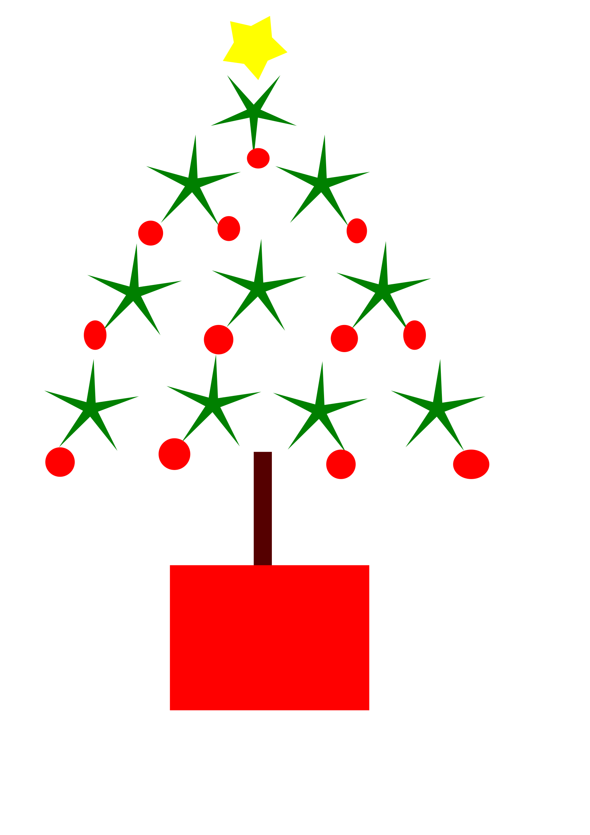

JOJACK’S HOLIDAY HOURS

^{DECEMBER 24TH} ^{-7:00AM-2:00PM}
^{DECEMBER 25TH – CLOSED}
^{DECEMER 26TH – 7:00AM-3:00PM}
DECEMBER 31ST – 7:00AM- 2:00 PM
^{JANUARY 1ST- CLOSED}
WE HOPE YOU ENJOY YOUR HOLIDAYS!
^{WE APPRECIATE YOUR PATRONAGE!}

